

**Applecross Senior High School**

Name:__________________________________

**Year 11 Physics /25**

**HEATING AND COOLING LAB VALIDATION TEST**

Specific Heat of Nickel Experiment

1. Bill and Susan set up their equipment to heat their nickel pellets as below. Susan suggests that there are several things wrong with this initial set up. List two major errors in the table below which may give invalid readings. Include explanations as to **why** you think that the errors or perceived errors will produce invalid data.

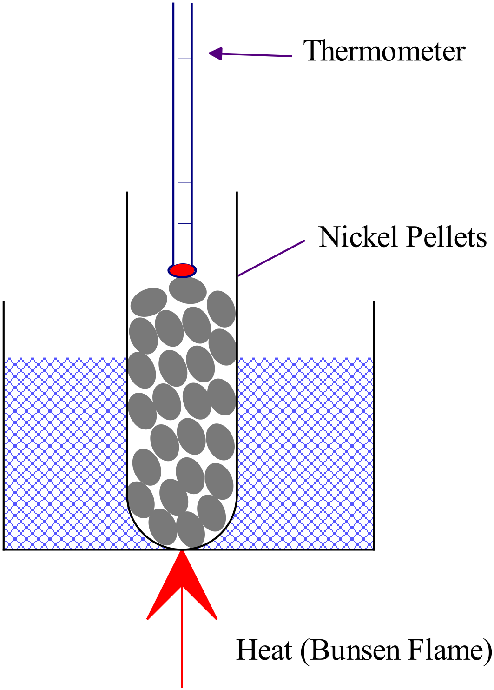

|  |  |
| --- | --- |
| Perceived Error | Explanation |
|  |  |
|  |  |

(4 marks)

1. During the experiment, Bill followed the instructions and heated the water bath to 90·0 °C. He then quickly put the test tube containing the dry nickel pellets, which were initially at room temperature, into the water bath and timed 1 minute while they heated. The pellets remained dry. Bill then removed the test tube containing the nickel pellets and quickly but carefully poured the pellets into the receiving water. He then measured the rise in temperature of the receiving water. He stirred gently a couple of times and took a reading as soon as the water had stopped rising in temperature.
2. What is the major flaw in Bill’s procedure? What effect would this have on the value for specific heat capacity he determined from his experiment? Explain.

(2 marks)

1. If Bill used the same thermometer to measure the temperature of the heating bath and the receiving water, what effect would this have on the specific heat capacity determined? Explain

(2 marks)

1. Alex and Rory apply their new found knowledge to calculate the specific heat of a recently discovered metal called Bradburium. Use the boys’ data as listed below to determine the specific heat capacity of Bradburium. Assume that no energy is transferred to the calorimeter or the environment. Show neat and full working.

Given Information

* mass of Bradburium sample = 57·26 g
* mass of receiving water = 45·0 g
* initial temp of Bradburium = 93·0 °C
* initial temp of receiving water = 19·0 °C
* final temp of receiving water and Bradburium = 23·0 °C

(4 marks)

Latent Heat of Fusion of Ice Experiment

1. If you used an aluminium calorimeter (c = 900 J kg-1 K-1)

of the same mass as the copper calorimeter

(c = 390 J kg-1 K-1) you used in your experiment,

would you need; **more, the same or less** ice

(*circle your response below*) to attain the same final

ice

temperature of the water as you achieved with the

copper calorimeter? With reference to the equation

water

for Qgained, explain your choice. (2 marks)

(2)

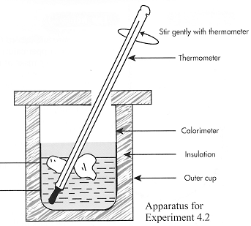

MORE THE SAME LESS

1. Michelle and Shirley carried out the Latent Heat of Fusion experiment, but realised afterward that they had made some mistakes. Their freezer (holding the ice) runs at

− 4·00 °C . As soon as the ice appeared wet, they started the experiment.

1. Explain how the ice can be wet, yet still be below zero degrees Celsius.

(1 mark)

______________________________________________________________________

______________________________________________________________________

To check the effect of this error, they decide to calculate the heat gained by the ice using a mean temperature of minus 2·00 °C for the ice (instead of 0 °C).

However, they also realise that they forgot to dry the ice and that the water film on the ice would account for approximately 1·0% of the total measured “ice mass”.

Use the girls’ data to calculate the total thermal energy gained by the 21·75 g of “measured ice” when a final water temperature of 3·00 °C is achieved, using the accepted values of specific heat capacities and latent heat of fusion for water.

Show full working used to obtain your answer below.

(4 marks)

1. Julia and Tony used ice from the same freezer, at - 4.0 °C and popped it quickly into the calorimeter before it could change temperature or melt. They were careful with all their measurements and recorded the results shown below;

Mass of copper calorimeter = 55.2 g

Mass of calorimeter plus water = 102.6 g

Initial temperature of calorimeter plus water = 38.7 °C

Initial temperature of ice = - 4.0 °C

Final temperature of calorimeter, water & ice mixture = 8.3 °C

Final mass of calorimeter, water & ice mixture = 121.1 g

Specific heat capacity of copper = 390 J kg-1 K-1

1. Use this information to calculate the latent heat of fusion of water. (4 marks)

Show all working.

1. Compare the calculated value from (a) to the accepted value on your data sheet, then list at least 3 possible sources of error in the experiment. (2 marks)

________________________________________________________________________

________________________________________________________________________

________________________________________________________________________

________________________________________________________________________

________________________________________________________________________

End of Test